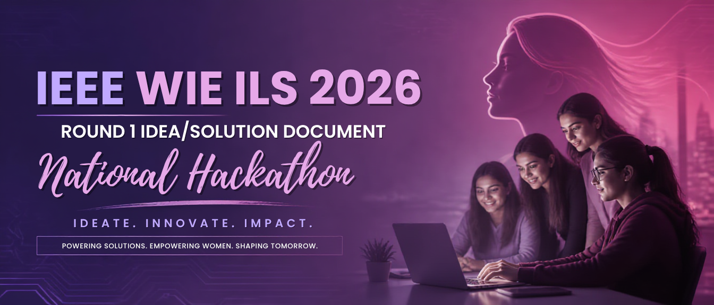
IEEE WIE ILS 2026
National Hackathon
Empower to Inspire: Thriving Together for an Inclusive and Sustainable Future
Submission Deadline: 25th August 2026
Submit as a single PDF, 12 pages max (including all sections, tables, and declaration)

Team Name | Track
Problem Statement # / Title | Solution Type:  ☐ Hardware ☐ Software ☐ Hybrid

What's Included
Do not alter this template's structure, section order, or formatting. Fill in only the marked fields/boxes. Total submission must not exceed 12 pages, including all tables, prompts, and the declaration page — submissions over 12 pages will not be evaluated. Be precise and to the point within each word-count budget.
Team Information
1. Problem Understanding
2. Proposed Solution / Idea
3. Innovation & Uniqueness
4. Feasibility & Implementation Plan
5. Expected Impact
6. Technology Stack
7. Team Member Roles
Originality & Declaration

Judging Criteria (Round 1)
Criterion (Weight) | What judges look for
Problem Understanding (10%) | Clarity, evidence, relevance to inclusion/sustainability
Solution & Innovation (25%) | Originality vs. existing solutions; how directly it solves the stated problem
Feasibility & Implementation (20%) | Realistic plan, timeline, resource awareness, risk mitigation
Expected Impact (20%) | Reach, measurability, alignment with inclusion/sustainability goals
Technology & Execution (15%) | Appropriate tech/hardware choices, prototype/demo maturity
Team & Presentation (10%) | Clear roles, well-organized submission, originality declaration complete

Team Information

Institution / Organization
City / State
Team Lead Name
Email
Phone
Team Members
Name | IEEE Member ID | Email | Phone
Round 1 — Idea / Solution

1. Problem Understanding
Guiding prompts:
• What specific problem are you addressing, and who is affected by it?
• What evidence, data, or field research supports that this problem is real and significant?
• Why does this problem matter now, in the context of inclusion and sustainability?

2. Proposed Solution / Idea
Guiding prompts:
• Describe your proposed solution/idea in clear, non-technical language.
• How does it directly address the problem stated above?
• Who are the intended users/beneficiaries, and how will they access or use it?
• Include a simple diagram, flow, or wireframe description if helpful.

3. Innovation & Uniqueness
Guiding prompts:
• What makes this solution different from existing products, papers, or approaches?
• List 2–3 comparable existing solutions and explain how yours improves on them.
• What is the single most novel element of your approach?

Plan & Impact

4. Feasibility & Implementation Plan
Guiding prompts:
• What are the key steps/milestones to build and deploy this solution?
• What resources, partnerships, or approvals would you need?
• What risks or constraints do you foresee, and how would you mitigate them?
• How would you validate/pilot this solution before scaling?

5. Expected Impact
Guiding prompts:
• Who benefits, and how many people/communities could this reach?
• What measurable outcomes would indicate success (e.g., metrics, KPIs)?
• How does this contribute to inclusion and/or sustainability specifically?
• What is the potential for long-term or scaled impact?

Technology & Team

6. Technology Stack
Guiding prompts:
• Hardware (if applicable): components, sensors, microcontrollers/boards, power source, and approximate cost of parts.
• Software: languages, frameworks, platforms, APIs, databases used.
• Note any AI/ML, IoT, or open-source components and why you chose them.
• If your solution is software-only or hardware-only, leave the other sub-section as "Not applicable."
• Have you conducted any survey, user interviews, or field research to validate your tech approach? ☐ Yes ☐ No — if yes, briefly summarize findings.

7. Team Member Roles
List only as many rows as your team size (1–6). Solo participants: complete just one row.
Member Name | Role | Responsibilities

Originality & Declaration

We, the undersigned team, declare that:
☐ The idea/solution submitted is original and has been conceived and developed by our team.
☐ This submission (or a substantially similar version) has not won a prior hackathon or competition award.
☐ Any third-party tools, datasets, libraries, images, or references used have been duly credited within this document.
☐ We understand that plagiarism, fabrication of data, or misrepresentation of authorship will lead to disqualification from IEEE WIE ILS 2026.

Team Lead Name & Signature (or e-signature):
Date:

Questions? Contact Madhav Maheshwari (+919588874415) or wieils2026@gmail.com

